<https://blog.devgenius.io/hardening-your-kubernetes-stack-pt-3-b260d45fe6e>

https://innablr.com.au/blog/what-is-pod-disruption-budget-in-k8s-and-why-to-use-it/

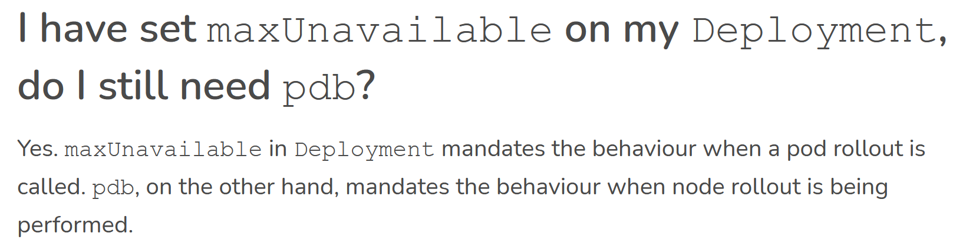

## **Pod Disruption Budget (PDB)**

When you make a change to the underlying infrastructure of your k8s cluster, you will want to make sure your pods maintain some level of availability. Setting a Pod Disruption Budget is one way to achieve this. A pod disruption budget is a resource in k8s that defines how many pods k8s should budget before disrupting pods. PDB defines the number or percentage of pods that can go down with maxUnavailable and the number or percentage of pods that must stay up with minAvailable. PDB applies the budget by using a selector. PDB currently supports ReplicaSet, StatefulSet, and Deployment.

apiVersion: policy/v1beta1

kind: PodDisruptionBudget

metadata:

name: test-pdb

spec:

minAvailable: 1

selector:

matchLabels:

app: test-app

